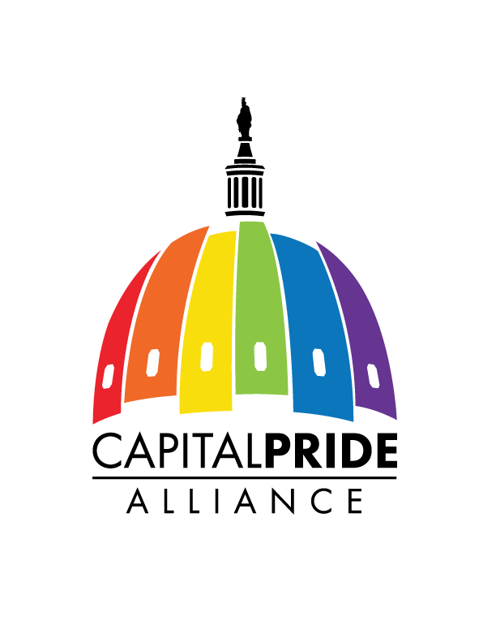
Mr and Miss Capital Pride 2016

Greetings!

On behalf of Capital Pride Alliance (Capital Pride), your former Mr & Miss Capital Pride’s, the board of directors, staff, and Production Team, thank you for your interest in the Mr and Miss Capital Pride Competition. In this packet you will find the information you need to assist in your preparations for this year’s competition:

- Official Rules and Regulations
- Scheduled dates & times for Mr and Miss Capital Pride 2016 Competition
- Explanation of Categories
- Official application and contestant information sheets
- Contestant bio information and special instruction sheets

Please bring your completed application & registration fee of $25.00 (made payable to) on Wednesday May 4, 2016.

The contestant orientation meeting will be held at Freddie’s Beach Bar at 7:00 pm on Wednesday May 4, 2016, 555 S 23rd St Arlington, VA 22202.

Any contestant who arrives late for the orientation meeting on May 4, 2016 will be deducted 10 points for every 5 minutes that they are late and will automatically become contestant # 1 for the Mr and Miss Capital Pride Competition (A contestant may send an official representative to attend the meeting. Please advise us in advance if this will be the case.)

If you have any questions or need clarification on the competition and categories, please do not hesitate to contact Destiny B. Childs via email empress2destiny@gmail.com or call 240-338-4536 or Patti Lovelace via email mminnier@aol.com or call at (703) 786-8460 or Alexandra B. Childs via email cphillips@capitalpride.org or call at (202) 714-4877.

We wish you all the best in your quest to capture the title of Mr or Miss Capital Pride 2016!

Sincerely,
Competition Directors
Capital Pride Formers

RULES AND REGULATIONS

- Contestants must be 21 years of age or older. (Proof of age is required).

- Any person, male or female, who has previously won the title of Mr or Miss Capital Pride, shall not be eligible to compete for the title(s) again.

- Contestants will be judged in the following categories: Pride Attire, Talent and Formal Wear/Evening Gown, and Question and Answer.

- Talent competition is limited to a maximum of 5 minutes. Contestants who exceed the time limit will be given a score of zero. Each contestant is given an additional 1 minute for set up and 1 minute for break down of props. The additional time may not be added to the performance time.

- Any contestant, or person affiliated with a contestant, who misappropriates the property of another contestant, violates any law regarding the abuse of alcohol or drugs, or is caught in the act of stealing will be disqualified and removed from the location of the competition. Unsportsmanlike conduct by a contestant or contestant’s entourage (dresser, dancer) before, during or after the competition will not be tolerated and is subject to immediate dismissal from the venue and competition.

- It is further understood by signature of this application and submission of this application, contestants and the contestant’s entourage (dresser, dancers) will take responsibility for any and all damage (should it occur) to Freddie’s Beach Bar and Restaurant before, during or after the competition.

- Each contestant will receive 100 administrative points upon arrival. Any contestant who arrives late will be deducted 10 points for every 5 minutes of tardiness.

- At no time during the competition shall a contestant or their helper(s) receive a gratuity of any kind during their time on stage.

- Each contestant will be allowed ONLY one (1) dresser at any given time. Contestants must remain in the assigned area at all times. Administrative points will be deducted from contestants who do not remain in the designated area. Dressers and Dancers as well as any other helpers with a contestant must pay at the front door before being allowed access to the dressing room.

- Each contestant that has back-up dancers or prop support staff shall be allowed to have them get ready 2 numbers prior to the talent performance. The contestant coordinator will strictly enforce this rule.

- Contestants are permitted to provide individual walking music for the category of *Pride Attire.

The winners of Mr and Miss Capital Pride 2016 will receive:
(Provided by Capital Pride)

Mr Capital Pride 2016:

Cash prize of $500.00, an official medallion & flowers
(Cash prize awarded as follows-$250.00 upon winning, $250.00 upon completion of his reign)

Miss Capital Pride 2016:
Cash Prize of $500.00, an official crown & flowers
(Cash prize awarded as follows-$250.00 upon winning, $250.00 upon completion of her reign)

Cash Prizes are subject to change without notice. The minimum cash prize for each winner shall be a minimum of $500.00 as stated above in the official prize package.

10. The winners of Mr & Miss Capital Pride 2016 will appear at selected official Capital Pride events during the week of the 41st Celebration of Pride in the Nation’s Capital and throughout the year. Events include, but are not limited to the following:
Heroes Gala
Music In The Night
Opening Party
Pride Parade
Pride Festival
Pride Splash & Ride
Holiday Heatwave
Pride Reveal
Mr and Miss Capital Pride 2016
*(2) Planned Fundraising Events during your reign
* Attendance for their official End of Year Step Down for the Title
All appearances will be scheduled and approved by Capital Pride Committee.

11. Winners will present themselves in a professional manner while holding the titles of Mr and Miss Capital Pride 2016. All final decisions are made by Capital Pride. Any misconduct throughout the year will be handled at the discretion of Capital Pride Alliance.

12. There will be scheduled events throughout the year that the winners will have the opportunity to attend and represent Capital Pride Alliance. You will be notified in a timely manner when these events are scheduled.

ITINERARY FOR MR and MISS CAPITAL PRIDE 2016

Mr and Miss Capital Pride 2016
Friday May 13, 2016
Freddie’s Bach Bar
555 S 23rd St Arlington, VA 22202

4:00 p.m. Doors open for all contestants

6:00 p.m. Roll call

8:00 p.m. Mr and Miss Capital Pride 2016 Begins (PROMPTLY)
Welcome & Introductions
Pride Attire (Mr and Miss)
Talent (Mr and Miss)
Formal Wear/Evening Gown & On-stage interview
Coronation (Mr and Miss.)

ACKNOWLEDGEMENT & WAIVER

I do hereby acknowledge that I have read and understand the rules and regulations as they pertain to the Mr and Miss Capital Pride 2016 competition and agree to abide by the same. I hereby agree to the required events set by Capital Pride and acknowledge that events may change at any time. Appearances are set by the Capital Pride Team and I agree to follow accordingly to all required appearances.

I hereby irrevocably waive all claims to any and all moving or still photographers against any and all parties involved in Mr and Miss Capital Pride 2016, which may result in my participation in said competitions.

Contestant Signature (given name) Date

Witness Signature Date

EXPLANATION OF COMPETITION CATEGORIES

Mr. and Miss Capital Pride 2016 / PRIDE ATTIRE:
Pride attire may be presented by the contestant in the form of his/her most imaginative and creative style. Pride attire is not limited to any one color, but should encompass the full scale of the rainbow. Make your own statement and get as creative as you like.

Miss Capital Pride 2016 / EVENING/FORMAL WEAR:
EVENING/FORMAL WEAR will be the most elegant outfit you wear during the competition (i.e. full length evening gown, or formal suit). It should complement your figure and make a statement of your personal style and taste. The outfit accessories should be in perfect condition. No strings should be anywhere on the outfit unless the style warrants it. There should be no tears in any part of the fabric and the outfit should be stain and wrinkle free. It is your responsibility to take care of the outfit and keep it in perfect condition during the competition.

Mr. Capital Pride 2016 / FORMAL WEAR:
Formal wear should be the most distinguished outfit you wear during the competition (i.e. black tie, tails, regular or modern tuxedo, no black jeans). It should complement you and make a statement of your personal style and taste. No strings should be anywhere on the formal attire. There should be no tears in any part of the fabric and the garment should be stain and wrinkle free. It is your responsibility to take care of your formal wear and keep it in perfect condition during the competition.

Mr. and Miss Capital Pride 2016 / ON-STAGE INTERVIEW:
Scoring will be based on personality and poise, the ability to communicate on a microphone in front of an audience, and the content of the answer given in relation to the question asked. This portion will immediately follow your presentation in Evening Gown or Formal wear.

Mr. and Miss Capital Pride 2016 / TALENT:
Talent is the highest point category in the Mr. & Miss Capital Pride 2016 competitions. Contestants will be judged on the quality of lip-sync, live vocal or other entertainment. Judges will be looking for lip sync or live singing ability. This will include but not limited to words to his/her song and proper phrasing within the song. If it is a live performance, is the talent of good quality? If there is choreography, the dancers should know the steps and steps should flow. If a member of your troupe does not know his/her part, points will be deducted from you score. Quality of set design and construction are not judged (note: allowed height is 6 feet). All contestants are responsible for their sets. Judges are instructed to deduct points if a set does not complement or enhance the talent and if the set falls or is broken during the talent phase of competition. All costuming and set design should fit the style and mood of the talent being presented. Is your talent appropriate for competition? Does your talent move, excite or educate the judges panel and the audience. It is important to know that you are being judged by a panel of judges and not by the audience. Keep in mind that subcategories make up the total score in each category of competition.

* NO FIRE, WATER OR HAZARDOUS MATERIALS ARE PERMITTED DURING ANY PORTION OF THE COMPETITIONS.

Contestants are allowed 1 minute for set up and 1 minute for breakdown of props

MR and MISS CAPITAL PRIDE 2016 Information

ALL APPLICATIONS MUST BE TYPED OR PRINTED LEGIBLY

Contestant Name: Contestant Number:

Given Name: Stage Name:

Birth date: E-Mail Address:

Contestant Telephone Number(s):

Sponsor(s):

Horoscope Sign:

Current Title(s):

Are there any physical disabilities, handicaps, or any other information you think we should know in order to better assist you? If so… please explain below.

Are you married or single? If so, how long?

My Favorite Hobbies are:

My most embarrassing moment:

My best advice to any performer:

If I could change one thing about the gay community, it would be:

People would use this word to best describe me:
My goals in life are:

My biggest pet peeve is:

What is the most important issue for the GLBT community in 2016?

What charity do you or have you raised money for in the GLBT community?

My Best Quality is:

Who influenced you the most to compete?

Pride means to me:

CONTESTANT NAME: CONTESTANT#:

Creative Pride Attire

What was your inspiration for this part of the competition?

Who designed and constructed the outfit?

CONTESTANT NAME: CONTESTANT#:

FORMAL WEAR/EVENING WEAR
(A 30 second description will be read during modeling)

Description of Formal/Evening Wear:

